2D URP PACKAGE!!!!! *

USE THIS PACKAGE IN URP PROJECTS AS ALL PARTICLES REQUIRE LIGHT *

To install package in unity click

Window > Package manager

Then click “+” > Add package from git URL

You can find the latest link on my GitHub here

<https://github.com/FilipRusiecki/ParticlesPackage>

Setup Light and layers required for the particles. *

**Click layers in top right corner of unity\***

**Now click “Edit layers” \***

**Now lets open Sorting layers and add 2 new layers “particle” and “casing”**

Create a 2D Global Light *

Right click Hierarchy > Light > Global Light 2D

Change settings as shown below (transform doesn’t matter)

**Change the “Target sorting Layers” as shown below.**

To use any of the particles simply drag and drop then into your hierarchy from the package.

**if the particle object has no sorting layer attached, attach one by clicking the particle.**

**Click add component in inspector > Sorting Group > then select particle**

All the particles from the package can be customized to your liking I have made some examples below so you can copy the different examples over.

Fire effect

**Camp Fire preset**

Change the following Emission and Limit Velocity over lifetime on the particle object *

**

Change the following Emission, Shape, Colour over lifetime and Limit Velocity over lifetime on the particle object *



Love effect

**Love burst effect**

LOVE EFFECT HAS 2 OBJECTS MAKE SURE TO CHANGE BOTH OF THEM TO SAME SETTINGS *

Freezing effect

**Freezing burst effect**

FREEZE EFFECT HAS 2 OBJECTS MAKE SURE TO CHANGE BOTH OF THEM TO SAME SETTINGS * 

Poison effect

**Poison burst effect**

POISON EFFECT HAS 2 OBJECTS MAKE SURE TO CHANGE BOTH OF THEM TO SAME SETTINGS *

Enchantment effect

**Enchantment burst effect**

ENCHANTMENT EFFECT HAS 2 OBJECTS MAKE SURE TO CHANGE BOTH OF THEM TO SAME SETTINGS *



Confetti effect

**Confetti effect v2 (ANY COLOUR)**

CONFETTI EFFECT HAS 2 OBJECTS MAKE SURE TO CHANGE BOTH OF THEM TO SAME SETTINGS *

**Bullet Casing**(drag and drop CasingSpawn.cs into assets folder and then attach it)

To Add bullet casing Simple make 2 layers one for player and one for bullet casing. And also make sorting layers and set them!  
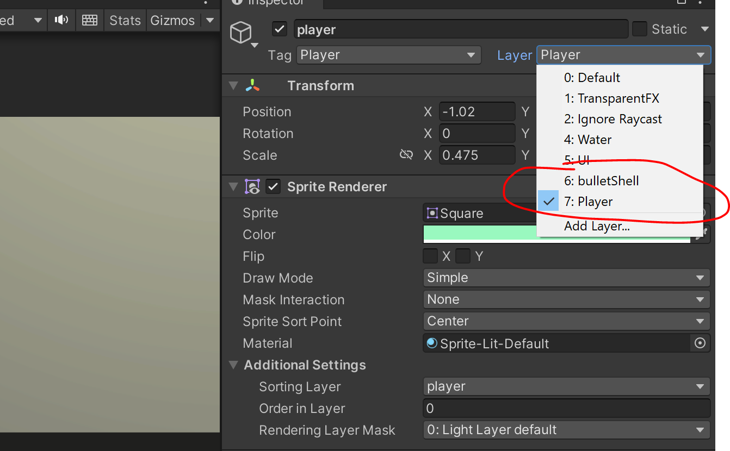  
then go to   
Edit>Project Settings>Physics 2D

And disable to physics between player and bullet casing

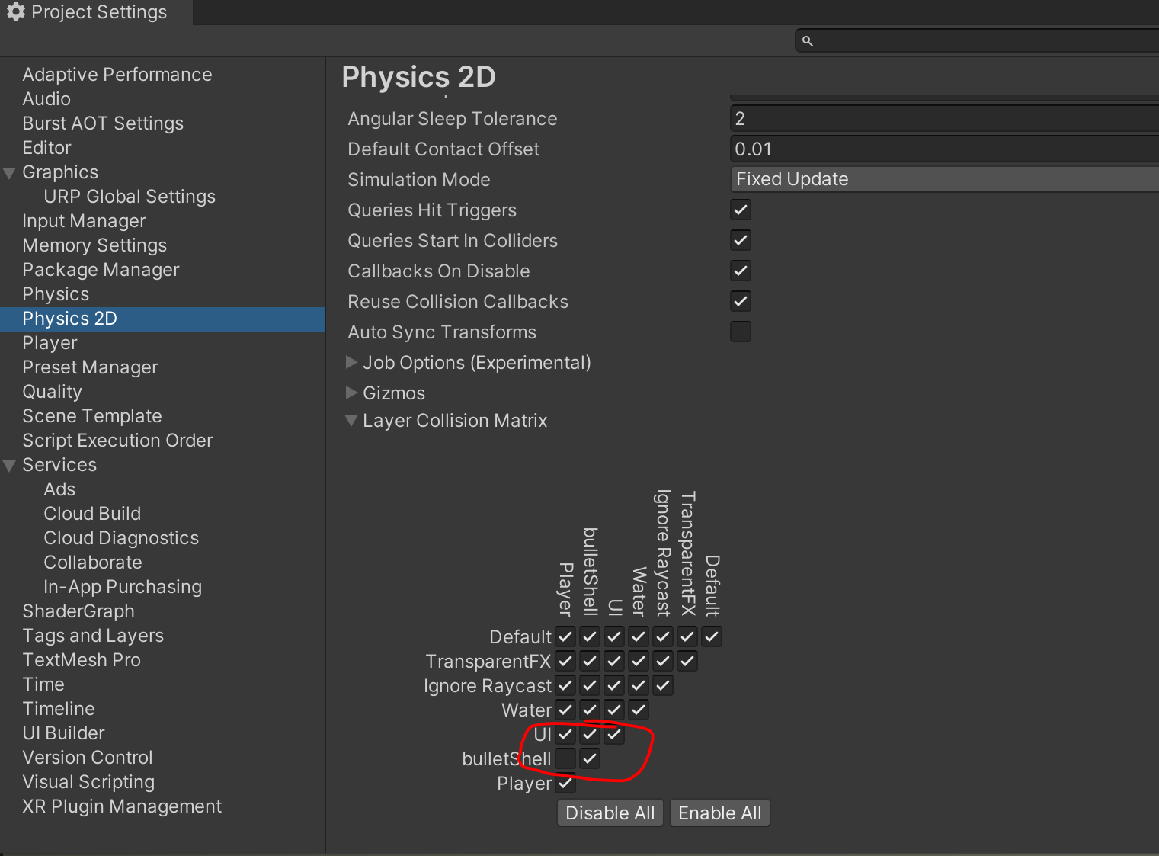

Use the script for bullet casing spawning that’s located in

Assets>UseTheseScripts>PutOnPlayer

And just fill in the fields to make it work

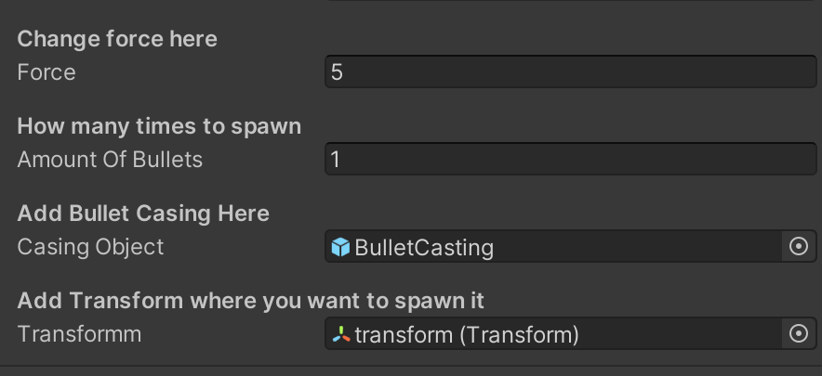

You can use any bullet casings you have but make sure they have rigid body on them or use a prefab that I have provided(warning it has a light attached to it)

**Blood Splatter Particle**

To use Blood Splatter Particle it is located in Resources/Prefabs folder

drag it into assets folder along side with splatterGround prefab located in the noNeedToUse folder, pull bloodHit and splatterGround into the hierarchy and unpack both of them, then attach the splatter ground as a sub emitter in bloodhit particle.

